Automated Visitor Counter with 7 Segment Display

The system is designed for optimum energy usage and is very beneficial in case if we want to count the number of people going to attend a particular event or any function thereby helps in collecting data by counting the number of people. This is done by simply incrementing the counter.
The system uses Infrared Sensor pairs in order to fulfil this purpose and thus saves a large amount of energy. Each pair consists of 2 sensor pairs placed at a certain distance from one another in the opposite direction. The IR transmitter is used to transmit IR rays straight to the receiver which receives the input and feeds this to an 8051 Microcontroller.
As soon as a person enters the area where the system is placed, it is detected by the IR sensor module and this info is fed to the microcontroller. The microcontroller process this input received. At this time the system also counts the number of people present and increments a counter on each arrival, this count is displayed on a 7 segment display.

Block Diagram
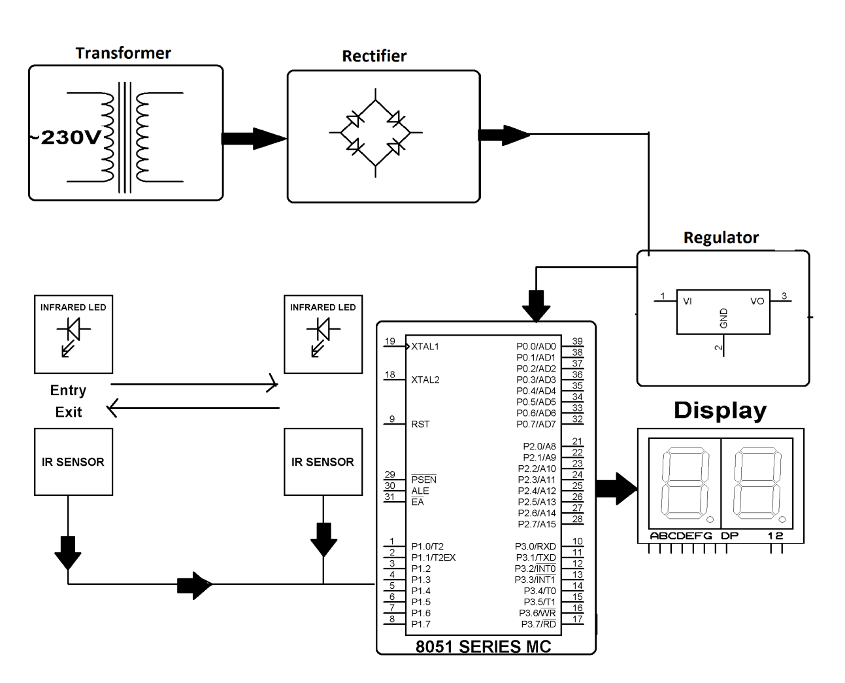

Hardware Specifications
- 8051 series Microcontroller
- Transistor
- Push Button
- Diodes
- Voltage Regulator
- IR Receivers
- LED
- IR LED’s
- 7- Segment Displays
- 555 Timers

Software Specifications
- Keil µVision IDE
- MC Programming Language: Embedded C

